## **11.2 User Interface Design for ABC Function**

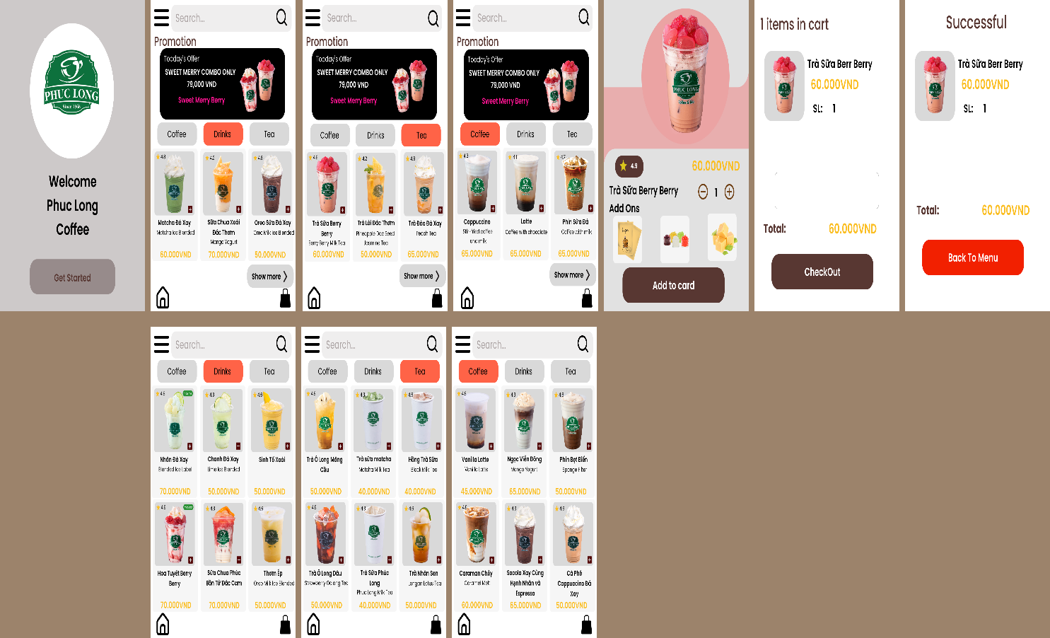

Link Test Function:

<https://www.figma.com/proto/TTBw4F8pXczDDWXiEmKQ8H/Nh%C3%B3m-3-UI-Coffe-Order?type=design&node-id=3-269&t=p9wmU3Z8FDHL4adL-0&scaling=scale-down&page-id=0%3A1&starting-point-node-id=3%3A269>